**Open Source Graphics & Animation Tools**

**MID-SEM EVALUATION**

**MARCH 2020**

**Submitted to**

**Dr. Durgansh Sharma**

**Professor, Cybernetics SCS, UPES**

**Submitted By**

Name: Vaibhav Gandhi

Roll No: 70

SAP ID: 500067190

B. Tech CSE (OSSOS) Department of Cybernetics

COMPUTER SCIENCE & ENGINEERING



**School of Computer Science**

**University of Petroleum and Energy Studies,**

**Dehradun – 248007: Uttarakhand**

Table of Contents

PHASE 2: PROJECT ON BLENDER 3

TOPIC: Jarvis 3

STEPS: 3

FINAL OUTPUT: 5

# PHASE 2: PROJECT ON BLENDER

# TOPIC: JARVIS

## STEPS:

1. Choose a name.
2. Open Blender and choose GENERAL.
3. Right click on cube->delete to delete the cube.
4. Click on ADD->Text.

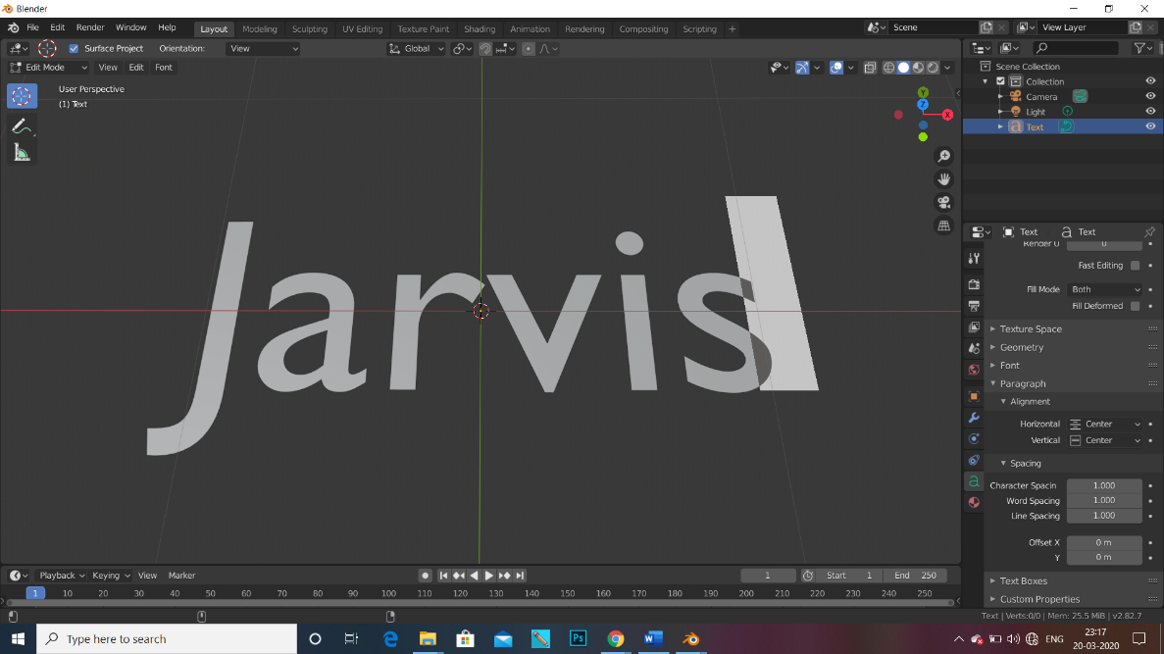

1. Set the alignment to the centre.
2. Add a circle and set it close to the text.
3. Add a point of light.
4. Add the key frames and make it rotate around the circle.
5. In OBJECT MODE, increase the strength of the light.

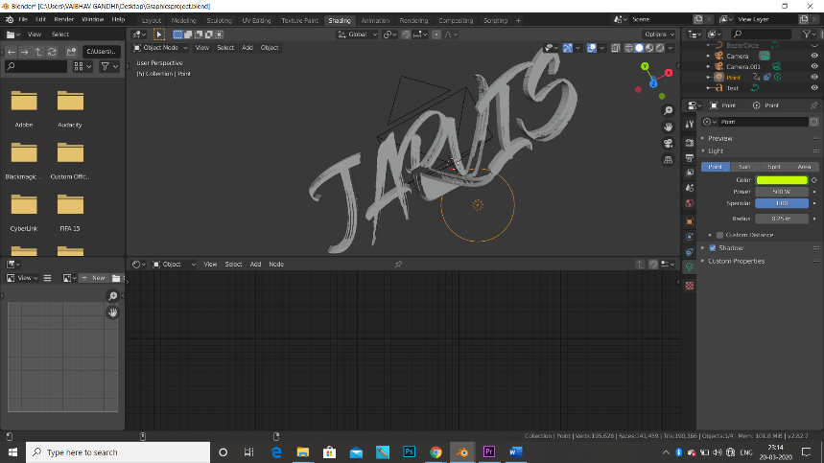

1. On the top toolbar, select the shading option.
2. Do the shading as per the requirement. 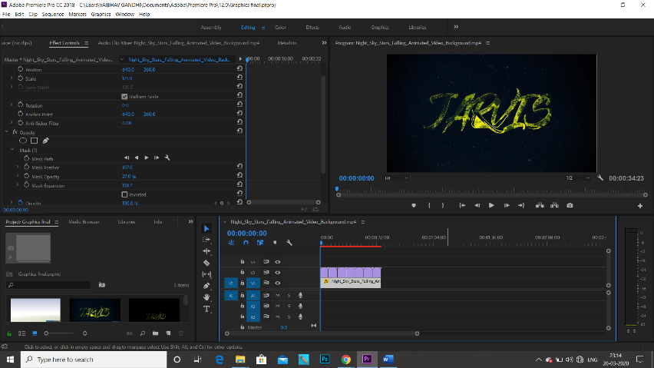
3. Select the layout option again.
4. Render the animation.
5. Open the software Adobe Premier Pro for background.
6. Add a background downloaded from the net and export it.

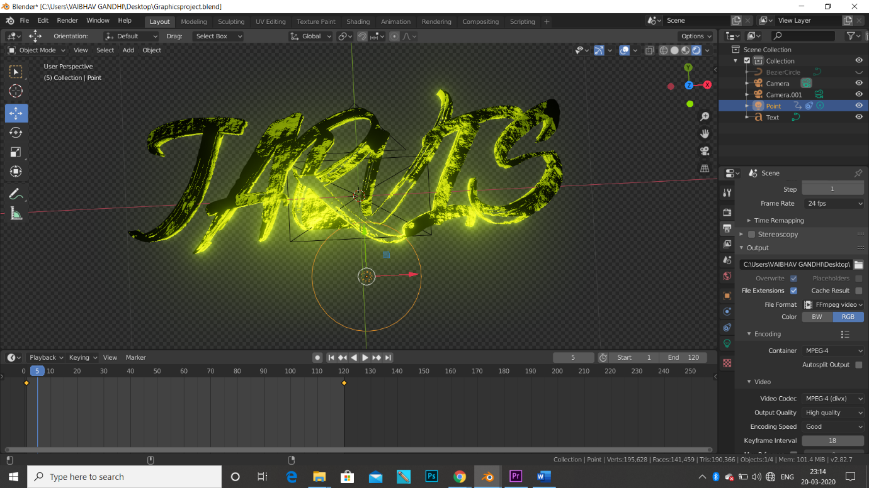

## FINAL OUTPUT:

